WETASKIWIN REGIONAL PUBLIC SCHOOLS
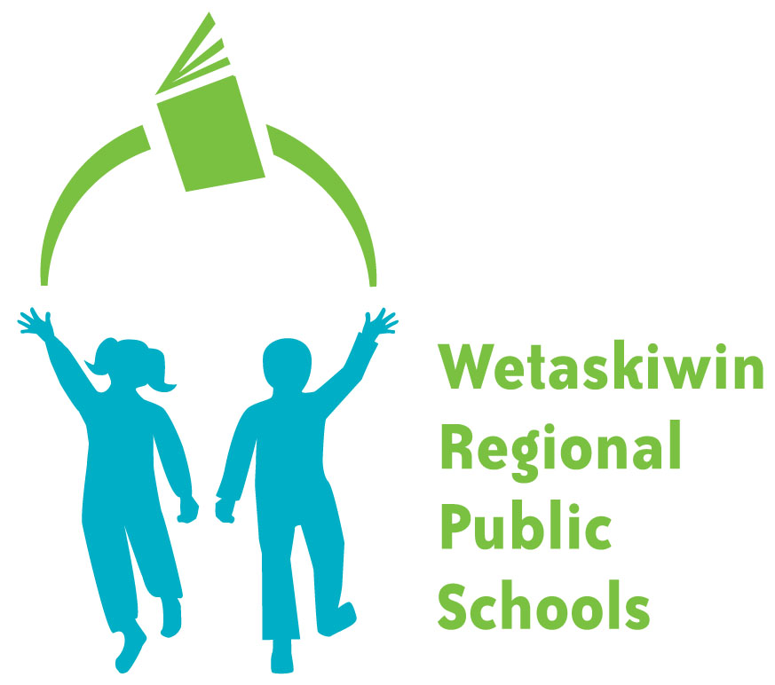
“Inspiring students to become the best they can be.”
FORM 505-2

WAIVER OF FEES APPLICATION FORM
- This application must be completed in it entirety to be considered for waiver of fees. The deadline for receipt of this application to the Director of Business Services will be December 15 of the current school year. No further applications will be accepted after this date.

- Fill out Section A with the Parent or Guardian’s Name, Address and Phone Numbers.

- Families on social Assistance may skip Section B and C by providing either:
  - A current statement from Social Services certifying that the applicant is on social assistance and the student(s) is/are dependent(s) of the applicant; or
  - Documents to prove the same; i.e. copy of current Social Services Medical Service Card
(note: applications for the current school year must be accompanied by an August or later Medical Service Card)

- All other applicants MUST complete Section B and provide the following documents to support the application.
- Photocopy of your last years Notice of Tax Assessment (statement issued by Revenue Canada taxation office is accepted), or
- Photocopy of your Options C printout
(Available by contacting Canada Customs and Revenue Agency 1-800-959-8281)

- Complete Section C if there are exceptional circumstances that are impacting your ability to pay the fee(s). You must provide detail information with supporting documents such as the following:
- Photocopies of your current reporting card and cheque stub for Employment Insurance Benefits (name and amount received must be visible)
- Letter from your present employer stating your current gross income
- Letter from school/university you are attending full time or photocopy of your student loan Notice of Assessment

- Sign and mail the completed application form with supporting document(s) to:
Wetaskiwin Regional Public Schools
Director of Business Services Mark “CONFIDENTIAL” on the
5515 – 47A Ave envelope
Wetaskiwin, AB T9A 3S3

- You will be notified of a decision in writing within approximately three weeks.

- The following chart of income levels outlines how the waiver of fees will be determined.
# of Adults and children
Per Household Full Waiver 50% Waiver
2 persons $25,000 $25,001-$30,000
3 persons $30,000 $30,001-$35,000
4 persons $35,000 $35,001-$40,000
5 persons $40,000 $40,001-$45,000
6 persons $45,000 $45,001-$50,000
7 persons or more $50,000 $50,000-$55,000

Note: Any application missing the above information will be returned to the applicant for completion. Statistics Canada information used as a guideline.

WETASKIWIN REGIONAL PUBLIC SCHOOLS
“Inspiring students to become the best they can be.”

FORM 505-2

WAIVER OF FEES APPLICATION FORM

The waiver applies to all Basic Educational, Enhanced Educational and Transportation Fees.

FEE WAIVER DEADLINE: DECEMBER 15
Please read instructions on the reverse side before completing this application.

SECTION A: (Please print) Name and Complete Address of Parent/Guardian
Last Name | First Name
Street Address City Province Postal Code
Home Telephone No. | Business Telephone No.
Name of Student (s) | School(s) Attending
SECTION B: Confidential Financial Information
Number of people Residing in household: | No. Adults:_______ No Children:_______
Please complete the following information based on your last income tax return(s) and attach copies of the Notices(s) of Assessment and the Options C printout(s) from Revenue Canada.
 | Total Income per line 150
Wage Earner #1 income | $
Wage Earner #2 income | $
Child Support Payments Received | $
TOTAL | $
SECTION C: Exceptional Circumstances (see guidelines on reverse- use separate page if necessary)
I certify that the information provided on this application and in any documents attached is correct and complete. I also understand that financial
and other information provided above is confidential.
Signature Date
The Freedom of Information and Protection of Privacy Act (FOIP Act), which came into effect for School Boards on September 1, 1993, sets controls and standards on how public bodies, such as school boards, collects, use and disclose personal information that is in their custody and under their control. Any personal information you do provide is protected under Alberta’s Freedom of Information and Protection of Privacy Act and will only be used for purpose for which it was collected.
If you have any questions about the collections, use or disclosure of information collected on this form, please contact the WRPS FOIP
Coordinator at 5515 – 47A Ave., Wetaskiwin, AB, T9A 3S3. The phone number is (780) 352-6018 and the fax is (780) 352-7886.

