WETASKIWIN REGIONAL PUBLIC SCHOOLS
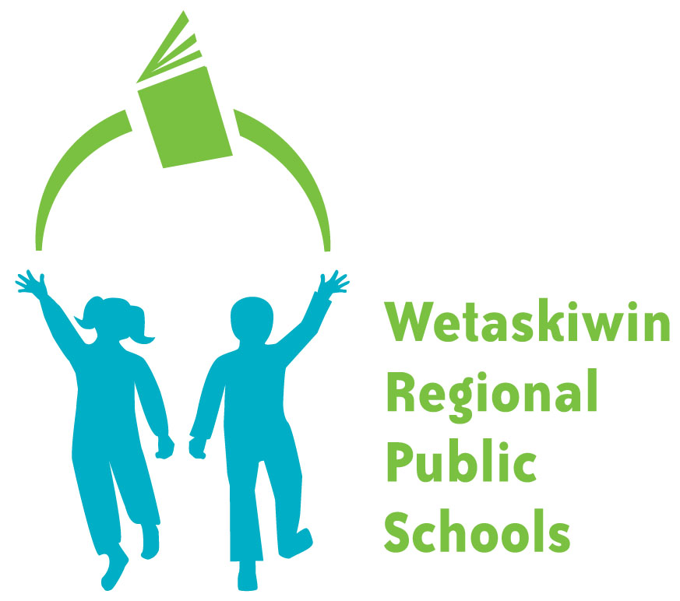
”Inspiring students to become the best they can be.”

FORM 180-2

Photograph Consent Form

As required by: Administrative Procedure 180 – Freedom of Information
and Protection of Privacy (FOIPP)

This Consent Form is used when photos are taken by the Division or one of its schools, where individual students are identified and the material is to be used for purposes beyond “regular operations of the Board” or on a school or division website.

I hereby consent for a photograph of

Name of Student
to be used for the following purposes:
Posted on WRPS Website and / or Social Media Account such as Facebook or Twitter

Comment:

Signature of Parent or Guardian
Date
Name of School
If you have any questions about the collection, use or disclosure of information collected on this form, please contact the WRPS FOIPP Coordinator:
Associate Superintendent – Business Services
5515-47A Avenue, Wetaskiwin, Alberta T9A 3S3
Phone: 780-352-6018 or e:mail: sengers@wrps.ab.ca

