WETASKIWIN REGIONAL PUBLIC SCHOOLS
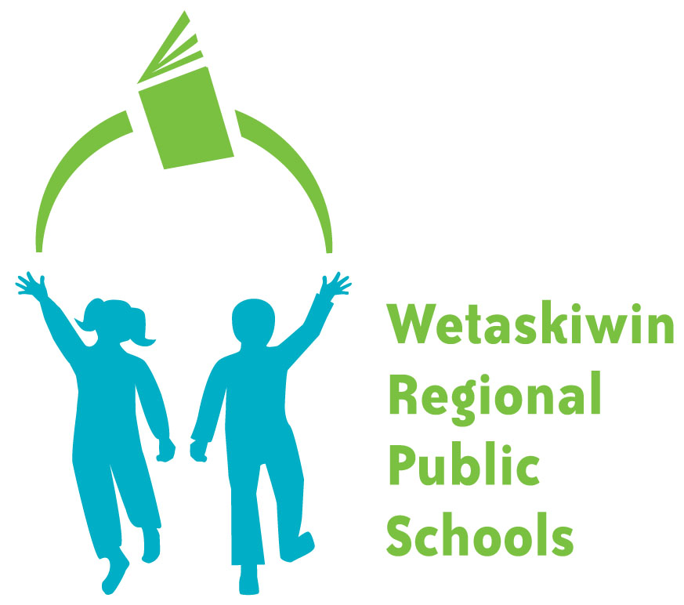
“Inspiring students to become the best they can be.”

FORM 16-3

PARENT PROVIDED TRANSPORTATION CLAIM FORM

Special Needs Coded | Special Needs  Directed |  |  |  | Program | Parent Provided

To be completed and returned by the 10th day of each month to the Transportation Department.
NAME OF CHILD | GRADE | SCHOOL

Attendance Dates must be checked off
MONTH |  |  | YR |  | SCHOOL(S)
1 | 2 | 3 | 4 | 5 | 6 | 7 | 8 | 9 | 10
11 | 12 | 13 | 14 | 15 | 16 | 17 | 18 | 19 | 20
21 | 22 | 23 | 24 | 25 | 26 | 27 | 28 | 29 | 30
31

MONTH TOTAL | COMMENTS

The shortest distance (one way) from home to point of delivery (school or nearest connecting point) is ______________________kilometers. Wetaskiwin Regional Public Schools Transportation Department agrees to pay transportation at the rate provided by Alberta Education and Board Policy.

I hereby certify that the above information is true and correct. Dates must be checked off and confirmed by the Principal or designate. Failure to do so may result in the delay of payment.

Signature of Principal/Designate: | Date:

PAYABLE TO |  | Mail | Direct Deposit
Street Address
City & Postal Code

Transportation Department Authorization ____________

Budget 2.409.600.70.0605___________________________

