WETASKIWIN REGIONAL PUBLIC SCHOOLS
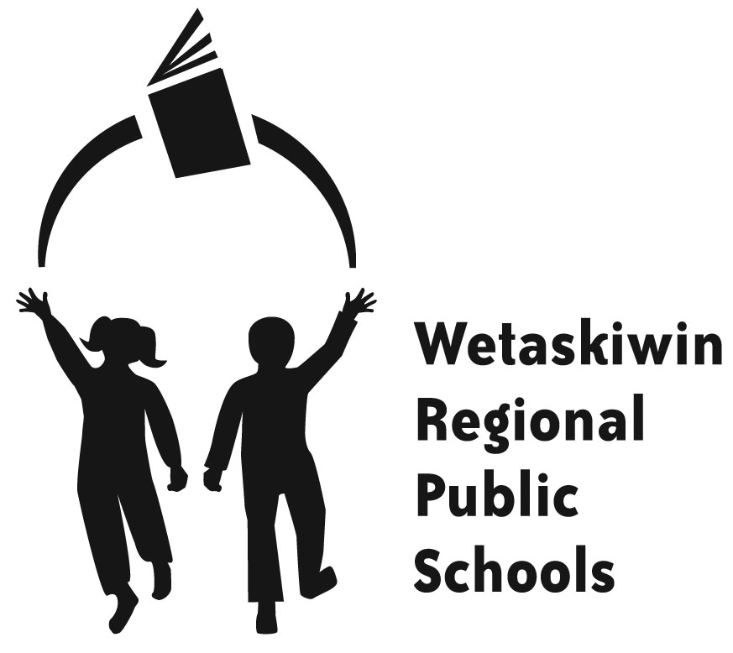
“Inspiring students to become the best they can be.”

FORM 16-2
PARENT PROVIDED TRANSPORTATION RATES

Where the transportation system is unable to provide transportation to either a student’s designated school, or to a school to which the student has been directed, the following rates, shall be paid:

$0.25 per kilometre to school and returning home (2 paid trips per day) where:
- The minimum paid per day shall be $15.00; or
- The maximum paid per day shall be $30.00

For Example:
Parent resides 15 kilometres from the school
15 km * 2 trips * $0.25 per kilometre = $7.50 per day, but with the minimum rate listed above, the parent will be paid $15.00 per day

Parent resides 45 kilometres from the school
45 km * 2 trips * $0.25 per kilometre = $22.50 per day, which is what the parent will be paid, since the daily rate is greater than the minimum daily rate, but less than the maximum daily rate

Parent resides 70 kilometres from the school
70 km * 2 trips * $0.25 per kilometre = $35.00 per day, but with the maximum rate listed above, the parent will be paid $30.00 per day

Rates are based on Alberta Education Transportation minimum and maximum funding rates. The maximum rate has been set at $6,748.00 for grades 1 – 12. ECS rates are $549 per year.

Rates will remain in effect until otherwise notified.

