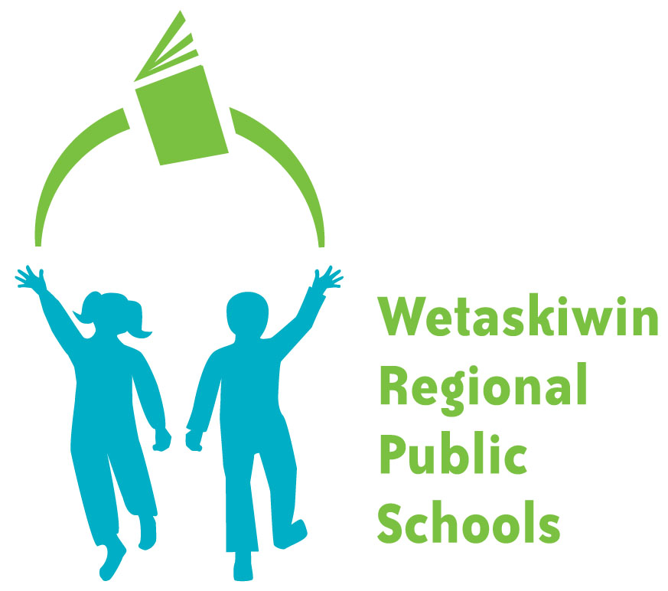
FORM 340-1
WETASKIWIN REGIONAL PUBLIC SCHOOLS
“Inspiring students to become the best they can be.”

SCHOOL BUS MISCONDUCT REPORT

Name of Student |  | Date
Name of School |  | Route #

Specify Run: Regular Extra-Curricular

OFFENCE

Smoking |  | Fighting |  | Changing Seats
Swearing |  | Standing Up |  | Throwing Things
Spitting |  | Late for Bus |  | Bothering Others
Noisy |  | Littering |  | Eating
Kneeling on seats |  | Turning Around
Other

Authorization: Bus Driver

SCHOOL USE ONLY

Dates of Previous Violations Reported:
Action Taken:

Principal/or Delegate Date

The Freedom of Information and Protection of Privacy Act (FOIP Act), which came into effect for School Boards on September 1, 1993, sets controls and standards on how public bodies, such as school boards, collects, use and disclose personal information that is in their custody and under their control. Any personal information you do provide is protected under Alberta’s Freedom of Information and Protection of Privacy Act and will only be used for purpose for which it was collected.

If you have any questions about the collections, use or disclosure of information collected on this form, please contact the WRPS FOIP Coordinator at 5515 – 47A Ave., Wetaskiwin, AB, T9A 3S3. The phone number is (780)352-6018 and the fax is (780)352-7886.

